**How to Setup JEE Development Environment..?**

By: Abdul Kareem (bitguiders@gmail.com)

**0: Development Environment directory structure**

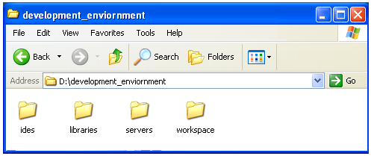

**1: Java Development Kit 7 [ JDK 7 ]**

<http://www.oracle.com/technetwork/java/javase/downloads/index.html>

**2: Eclipse Indigo 3.7.x :**

<http://www.eclipse.org/downloads/download.php?file=/technology/epp/downloads/release/indigo/R/eclipse-jee-indigo-win32.zip>

**3: Jboss 7as:**

<http://www.jboss.org/as7.html>

### [JBoss Tools 3.3 Installation From Update Site](https://www.jboss.org/tools/download/installation/update_3_3.html)

**4: Enviornment Variables:**

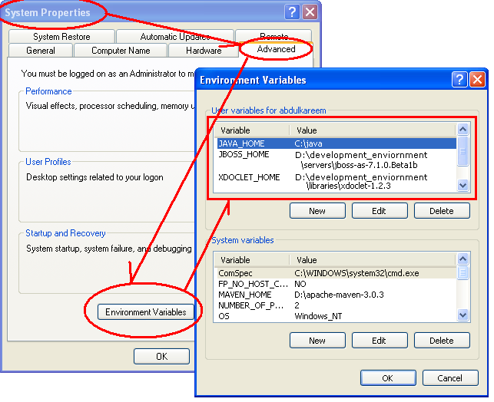

**Quick Start:**

# [Getting Started Developing Applications Guide](https://docs.jboss.org/author/display/AS7/Getting+Started+Developing+Applications+Guide)

# [Starting JBoss AS from Eclipse with JBoss Tools](https://docs.jboss.org/author/display/AS7/Starting+JBoss+AS+from+Eclipse+with+JBoss+Tools)